General Education
UNIV 101  UNIV 301 | Exploring Perspectives – Artist  Exploring Perspectives – Humanist  Exploring Perspectives – Natural Scientist  Exploring Perspectives – Social Scientist | Building Connections (1 of 3)  Building Connections (2 of 3)  Building Connections (3 of 3)/ Civics Institution (fall 2026 and later)
Major (Emphasis) Foundation
*Emphasis foundation courses (6 total). must complete these courses before you are eligible to declare an emphasis or enroll in internship units
*ENGL/WRIT 101  First Semester Composition  *ENGL/WRIT 102  Second Semester Composition  *Second language  First semester | *MATH 107 or higher  (MATH 112 College Algebra encouraged)  **online requires MATH 112 or higher** | ‘C’ or better required:  *HPS 178  Personal Health and Wellness (EP – Social Scientist)  *HPS 200  Introduction to Public Health
Major Foundation Courses Continued
not required prior to declaring emphasis
Second Language  Second Semester Proficiency  Second Language  Third Semester Proficiency  Second Language  Fourth Semester Proficiency | Communications Skills  Choose 1 Course  ‘C’ or better required:  COMM 101 Intro to the Study of Comm.  COMM 114 Into to Interpersonal Comm.  COMM 117 Culture and Communication  COMM 119 Public Speaking  PR 201 Intro to Public Relations  COMM 209 Intro to Communication Technology  COMM 314 Creative Professional Comm.  GHI 414 Intercultural Comm. for Health Sciences | Statistics Skills  Choose 1 Course  ‘C’ or better required:  BIOS 216  Understanding Our Health Through Data (main campus only)  BIOS 376  Introduction to Biostatistics
Major Core Requirements
Major Core Courses  ‘C’ or better required:  PHP 210 Later Life Health and Wellbeing Across Populations  PHP 322 Health Education and Ethical Leadership  HPS 403 Applications in Health Promotion: Behavioral Theories  HPS 404 Fundamentals of Evaluation  HPS 405 Biology of Public Health  EHS 425 A Public Health Lens to Climate Change | Emphasis (15u)  Emphasis Course (1 of 5)  Emphasis Course (2 of 5)  Emphasis Course (3 of 5)  Emphasis Course (4 of 5)  Emphasis Course (5 of 5) | Public Health Practicum & Field Work (9u)  HPS 497E Practicum – Public Health for Community Wellness  HPS 394 Practicum – Prep for Field Work  HPS 493A Field Work in Public Health  Emphasis Options Link
Minor (18u+)  Minor Course  Minor Course  Minor Course  Minor Course  Minor Course  Minor Course | NOTES: GRADUATE WITH BA DEGREE WITH A MINIMUM OF 120 UNITS  - MINIMUM 2.0 MAJOR & CUMULATIVE GPA REQUIRED  - 9 UNITS OF GENERAL EDUCATION COURSES MAY ALSO BE USED WITHIN MAJOR/MINOR/CERTS  - 6 UNITS OF PH COURSE WORK MAY OVERLAP WITH OTHER MAJOR/MINOR/CERT

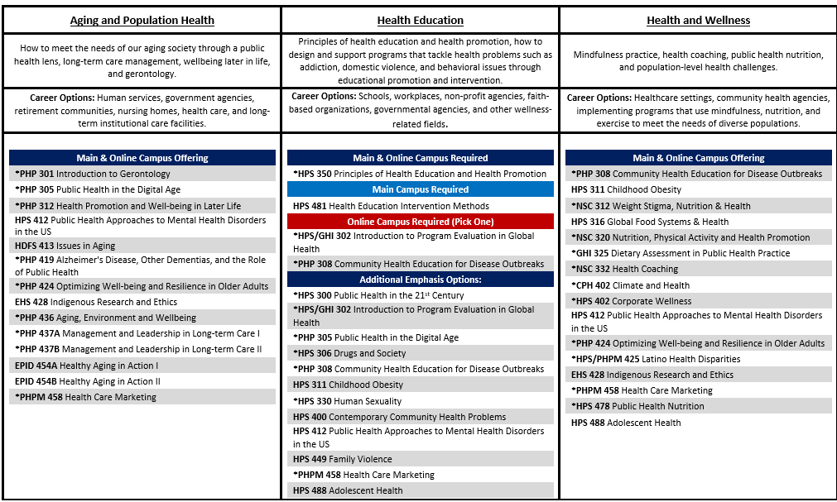

*Courses most commonly available on online campus
Check for current emphasis offerings: Bachelor of Arts Curriculum | Zuckerman College of Public Health

