Public Health Internship Orientation Worksheet for Undergraduates
Planned for Spring 2021

Name: Click or tap here to enter text.

Preferred Name: Click or tap here to enter text.

UA Student ID Number: Click or tap here to enter text.

UA Email Address: Click or tap here to enter text.

Are you enrolled in the fully online Bachelor’s in Public Health Program? YES or NO Click or tap here to enter text.

NOTE: This internship orientation is only for undergraduate students who plan to complete their public health internship during Spring semester 2021. If you are planning on completing an internship in a different semester, feel free to watch the video but realize that you will need to complete a future orientation, as it is important for you to have the most up-to-date information.

INSTRUCTIONS:
- Watch the internship orientation video (available here)
- Type in the answers to the questions below. Provide your digital signature.
- Email your completed sheet to Dr. Laura Gronewold at laurag1@email.arizona.edu. This worksheet must be completed before you can gain access to the non-credit D2L site, Public Health Internship Prep Course, and added to public health internship units (HPS 493A, HPS 493H, or HPS 493B).

QUESTIONS:

- Define public health in your own words. (This is important to do because your internship must be public health related in order to be counted for public health credit!)
Click or tap here to enter text.

- What topics in public health interest you most? What subject area are you considering pursuing for your internship?
Click or tap here to enter text.

- Why do clinical-based experiences not count for the public health internship?
Click or tap here to enter text.

- Why is an internship experience required of public health students?
Click or tap here to enter text.

- Highlight or bold the semester are you considering completing your internship in:
  - Spring 2021
  - Summer 2021
  - Both
  - I am still deciding

- Highlight the internship section you are considering for enrollment for the Spring 2021 term:
  - HPS 493A – required internship for 6 units
  - HPS 493A – required internship for 3 units
  - HPS 493H – honors internship for 6 units
  - HPS 493H – honors internship for 3 units
  - HPS 493B – elective internship for 6 units
  - HPS 493B – elective internship for 3 units
  - I am still deciding

- How many total contact hours are needed for the:
  - 6 unit internship? Click or tap here to enter text.

  - 3 unit internship? Click or tap here to enter text.

- Why is it recommended that students limit their enrollment in other units during the internship semester? Please remember that the University maximum credit limit (19 units) cannot be exceeded during the internship semester(s).
Click or tap here to enter text.

- Why is it be important to speak with the agency about the total contact hours required?
Click or tap here to enter text.

- For the Spring 2021 term, when can you start counting your internship hours?
Click or tap here to enter text.

- What are the responsibilities of the student?
Click or tap here to enter text.

- Why is it recommended that you give the pages of the Internship Manual “Responsibilities of the Agency and Preceptor” to organizations that you reach out to and/or where you interview?
Click or tap here to enter text.

- What are some tips on finding an internship?
Click or tap here to enter text.

- Visit the College’s HUB website (see the last two pages of this worksheet for access tips) and describe at least one undergraduate internship opportunity posted.
Click or tap here to enter text.

- Visit the University’s Handshake platform at https://arizona.joinhandshake.com/login and describe at least one internship opportunity posted.
Click or tap here to enter text.

- Read here about elevator speeches: https://www.thebalance.com/elevator-speech-examples-and-writing-tips-2061976.
What are three to five points that you would want to include in your 30-second elevator speech if you met your dream internship agency/preceptor on the elevator today?
Click or tap here to enter text.

- What topics should you include when you orient the agency?
Click or tap here to enter text.

- Repeat one of the pieces of advice shared by the students and what it means for your plans and strategy regarding your internship search.
Click or tap here to enter text.

- What are your goals for your internship?
Click or tap here to enter text.

- Given your goals, google your interests in the public health field (for example, “HIV,” “occupational health,” “health literacy”) and the location (for example, “Tucson,” “Oro Valley,” “Phoenix,” or “Prague, Czech Republic”) where you hope to intern. Click on the search results to learn more about potential internship agencies. What are some of the results that come from your search?
Click or tap here to enter text.

- What is the deadline for the required forms for Spring 2021 enrollment?
Click or tap here to enter text.

- Where do you submit the Work Plan, Preceptor Agreement, and CoVid Risk Assessment?
Click or tap here to enter text.

- How many hours (outside of your agency contact hours) should you expect to spend on the academic portion of your internship course?
Click or tap here to enter text.

- What questions, concerns, and/or feedback do you have for Dr. Gronewold, the Internship Instructor, after viewing this public health internship orientation video?
Click or tap here to enter text.

NOTE: Students will get access to the D2L site—Public Health Internship Prep Course site—after emailing a completed worksheet to Dr. Laura Gronewold (laurag1@email.arizona.edu).

Work Sheet Submission:
I attest that the information provided in this work sheet is my own work. Note: plagiarism and/or unethical behavior (including getting answers from a friend/peer and not watching the video) will result in a report of academic misconduct/violation of the University’s Code of Academic Integrity.

Digital Signature – type name Date

How to navigate to Internship Opportunities on the MEZCOPH Student HUB:
- Navigate to the College of Public Health’s website: www.publichealth.arizona.edu
See the HUB tab.
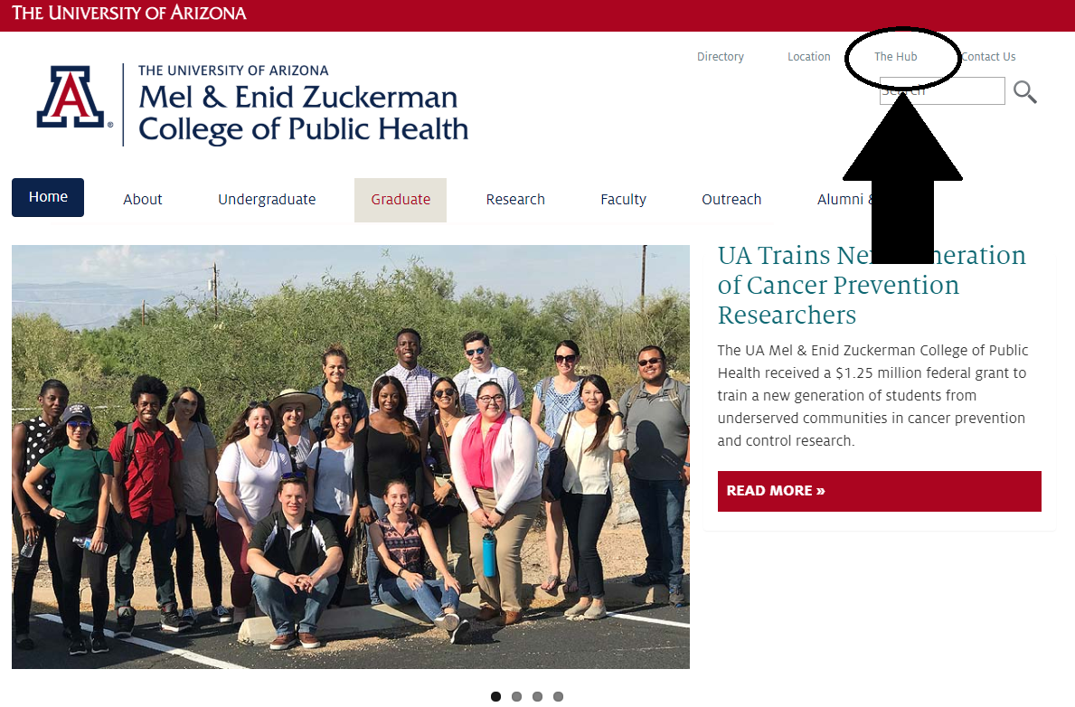

- Log in to the HUB with your UA NetID
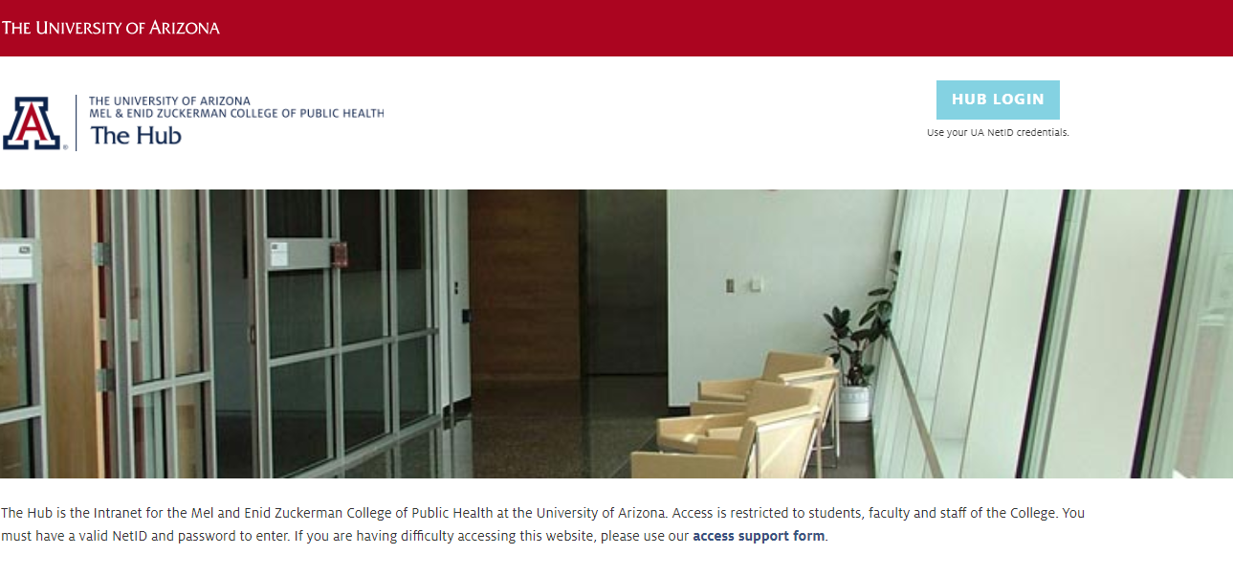
- Click on the Undergraduate Student tab and choose the Internships tab. Next, choose the link that takes you to Undergraduate Internship Opportunities.

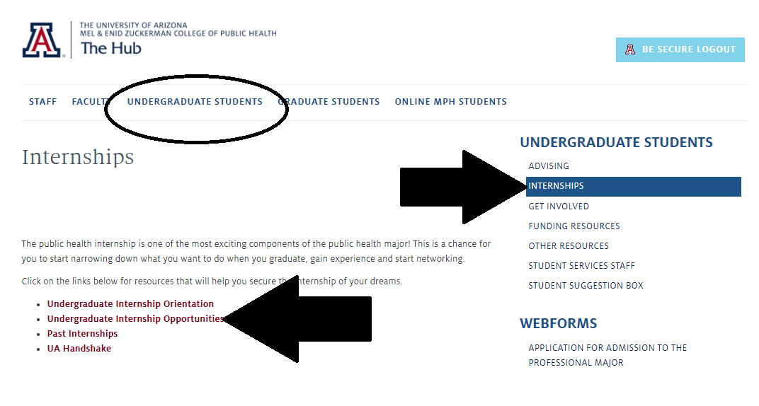

- Click each listing to review the specific internship information.
