Public Health Internship Orientation Worksheet for
Undergraduate Internships Planned for the Summer or Fall 2017 Terms

Name:

UA Student ID Number:

UA Email Address:

NOTE: This 59 minute internship orientation is only for undergraduate students who plan to complete their public health internship in the summer or fall of 2017. If you are planning on completing an internship in a different semester, feel free to watch the video but realize that you will need to complete a future orientation, as it is important for you to have the most up-to-date information.

INSTRUCTIONS:
- Watch the internship orientation video (available here: https://publichealth.arizona.edu/undergraduate/internships)

- Type in the answers to the questions below. Provide your digital signature.

- Email your completed sheet to Stephanie Springer at stephks@email.arizona.edu. This worksheet must be completed before you can be gain access to the D2L site, Public Health Internship Orientation, and added to public health internship units (CPH 493A or 493B).

QUESTIONS:
- Who is the public health undergraduate internship director?

- Define public health in your own words. (This is important to do because your internship must be public health related in order to be counted for public health credit!)

- Per Dean Tisch, what is the purpose of the internship? How does the student benefit and how does the community benefit?

- Given the discussion about internship criteria, what are some examples of public health internship agencies? (You can list those mentioned in the video or come up with your own ideas.)

- Describe a few of the differences that Stephanie mentioned that differentiate Public Health from Clinical Health. With that in mind, why do clinical based experiences not count for the public health internship?

- How many total contact hours are needed for the:

  - Six unit internship?

  - Three unit internship?

- For the summer term, when can you start counting your internship hours?

- For the fall term, when can you start counting your internship hours?

- How many hours (outside of your 250 contact hours) should you expect to spend on the academic portion of your internship course?

- What are the pre-requisite criteria for:

  - CPH 493a (required internship)?

  - CPH 493b (elective internship)?

- What are the responsibilities of the student?

- What are the responsibilities of the intern?

- Why is it recommended that you give the pages of the Internship Manual “Responsibilities of the Agency and Preceptor” to organizations that you interview at?

- What are some tips on finding an internship?

- Visit the College’s HUB website (see the last two pages of this worksheet for access tips) and describe at least two undergraduate internship opportunities posted.

- What can you find on the D2L site: “Public Health Internship Orientation”?

- What does it mean to ‘think outside of the fish bowl’?

- How did Stephanie find her public health internship?

- Now that you have heard an example of an elevator speech, what are three to five points that you would want to include in your 30-second elevator speech be if you met your dream internship agency/preceptor on the elevator today?

- What are your goals for your internship?

- Given your goals, google your interests in the public health field (for example, “HIV”, “occupational health”, “health literacy”) and the town (for example, “Tucson”, “Oro Valley”, “Prague, Czech Republic”) you hope to intern in. Click on the search results to learn more about potential internship agencies. What are some of the results that come from your search?

- When are the work plan, preceptor agreement, and student placement agreement due for Summer 2017 enrollment?

- When are the work plan, preceptor agreement, and student placement agreement due for Fall 2017 enrollment?

- Where do you turn the work plan and preceptor agreement in?

- What “counts” for internship contact hours?

- What are at least three keys to a successful internship that Maggie mentioned?

- What questions do you have for Stephanie, the Internship Director, after viewing this public health internship orientation video?

NOTE: Students will get access to the D2L site, Public Health Internship Orientation site after emailing a completed worksheet to Stephanie Springer.

Work Sheet Submission:
I attest that the information provided in this work sheet is my own work. Note: plagiarism and/or unethical behavior (including getting answers from a friend/peer and not watching the video) will result in a report of academic misconduct/violation of the University’s Code of Academic Integrity.

Digital Signature – type name Date
How to navigate to Internship Opportunities on the MEZCOPH Student HUB:
- Navigate to the College of Public Health’s website: www.publichealth.arizona.edu
See the HUB tab.
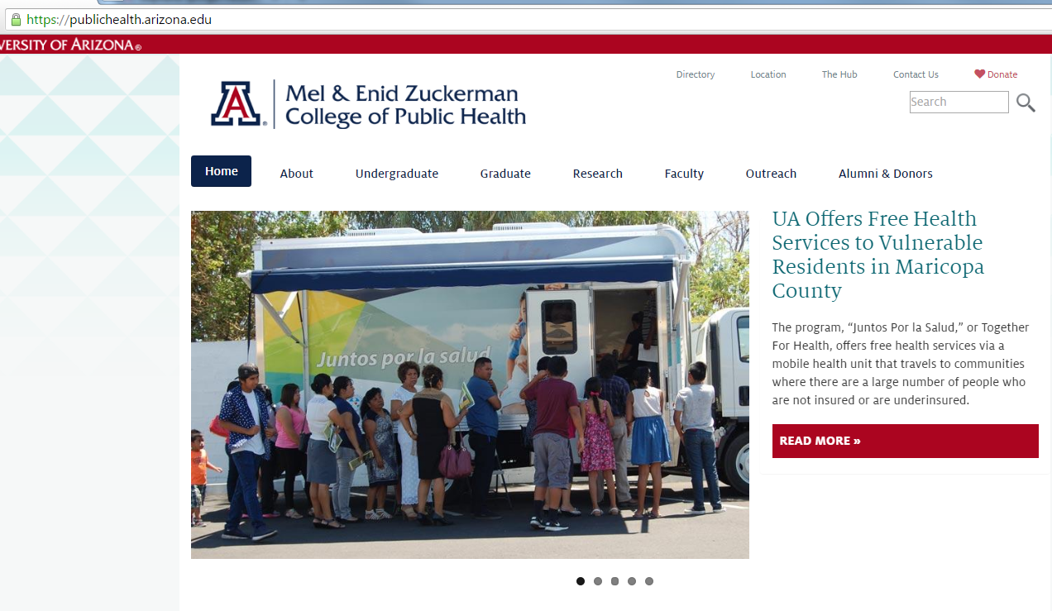
- Log in to the HUB with your UA NetID
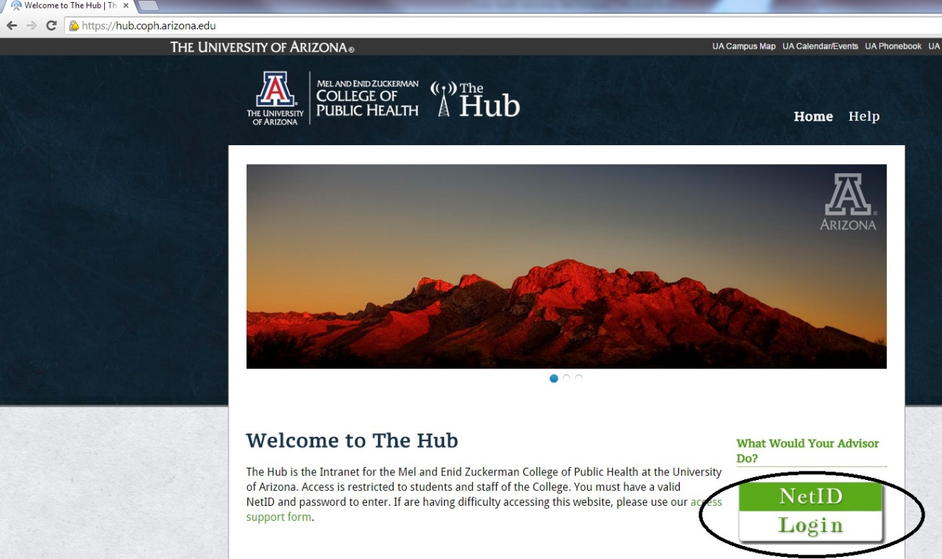
- Click on the Student tab and choose the Internship Opportunities tab

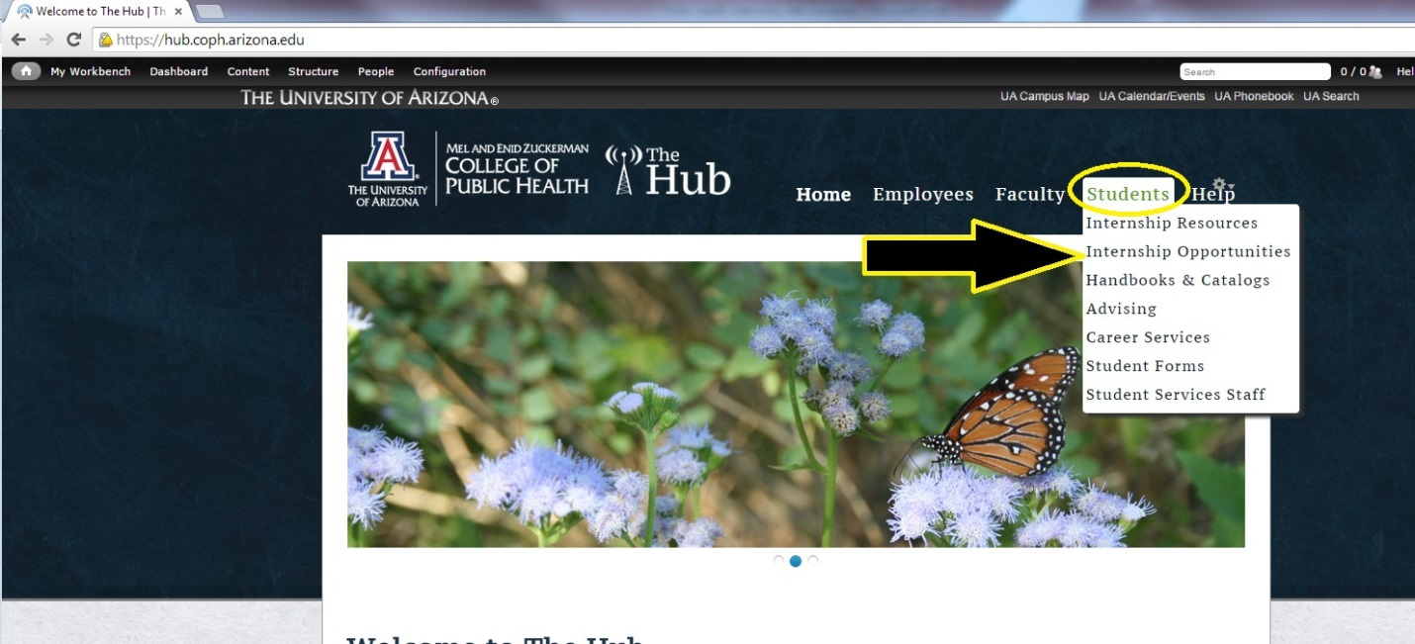

- Scroll down to review the Undergraduate Internship Opportunities. Click on the links to review the specific internship information.
